This is an example of how to optimize a design with one stimulation period lasting 9 s, with a variable rest length between stimulation periods. We’d like to optimize the detection power for the stimulation vs. rest.

>> model_setup_ui
Model setup user-interface: for specifying a design matrix.
by Tor Wager, version a1
___________________________________________________________
Enter TR in s 2
Enter run length in s 360
Condition setup:
Press return when asked for onsets for a condition to exit.
___________________________________________________________
Onsets for condition 1 in s [0 0; 10 30]; % first pair of numbers = range of onsets,
%2nd pair = % range of lengths
Parts for condition 1: enter 1 or num parts 1
Onsets for condition 1 part 1 relative to: 1 for start of trial, 2 for prev. part 1
Onsets in s for condition 1 part 1 from start of trial 0
Stimulation length in TRs for condition 1 part 1 4.5
Convolve condition 1 part 1 with canonical HRF? 1/0 1
Onsets for condition 2 in s

% check out an example model:
[X,paramvec] = construct_model(mspec,conditions,[]); figure;imagesc(X); colormap gray
[evtonsets] = paramvec2onsets(mspec,conditions,[]);

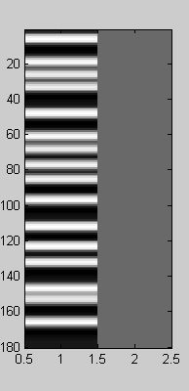

% Test the GA with a small generation size and number of generations, to make sure it works:

>> [evtonsets,X,bestp,meff] = ga2(20,5,conditions,mspec);
Gen 1: best eff is 564.1095, model 7, time = 0.17, elapsed = 0
Gen 2: best eff is 564.1095, model 1, time = 0.11, elapsed = 1
Gen 3: best eff is 578.5667, model 19, time = 0.11, elapsed = 1
Gen 4: best eff is 580.5683, model 18, time = 0.11, elapsed = 1
Gen 5: best eff is 586.7395, model 12, time = 0.11, elapsed = 1

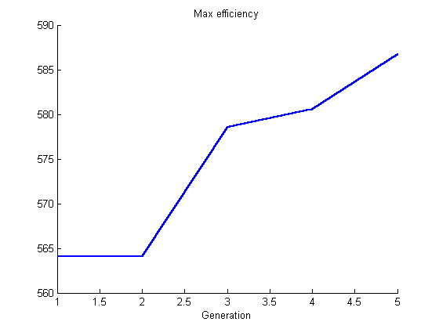

Looks good. Now run it with a more substantial population:

[evtonsets,X,bestp,meff] = ga2(500,1000,conditions,mspec);

Note: this simulation will converge rather quickly on a semi-blocked design, with mini-blocks of 2 or 3 stimulation periods followed by 20 s or so of rest. To optimize for detection of the shape of the HRF to each event, try:

conditions.subcond.convolve = 0;
conditions.subcond.hrfest = 15; % 15 TRs = 30 s
conditions.subcond.stimlength = 1;
conditions.stimlength = 1;

This produces a design matrix like this:
